Resolution of the PAFD’s Public Meeting on 9th of April, 2016 in Frankfurt am Main Germany
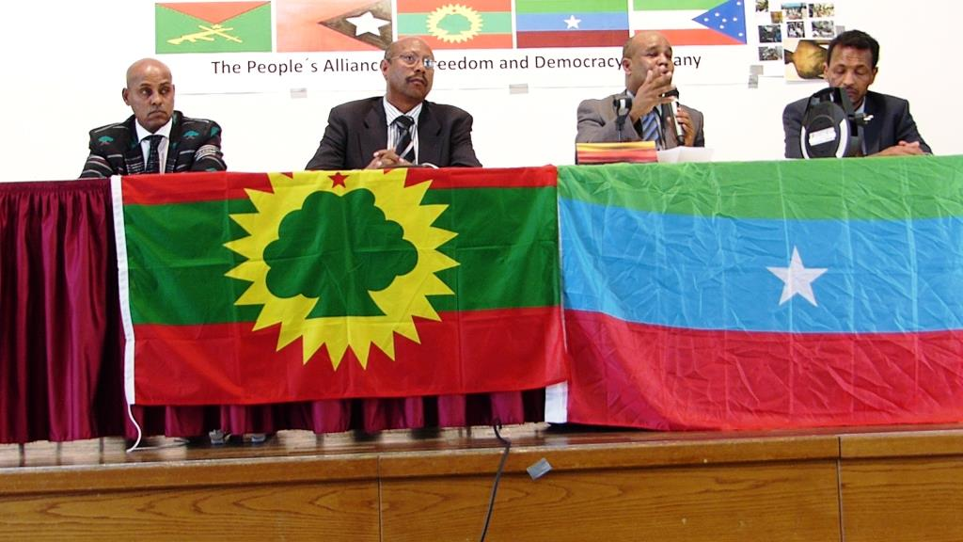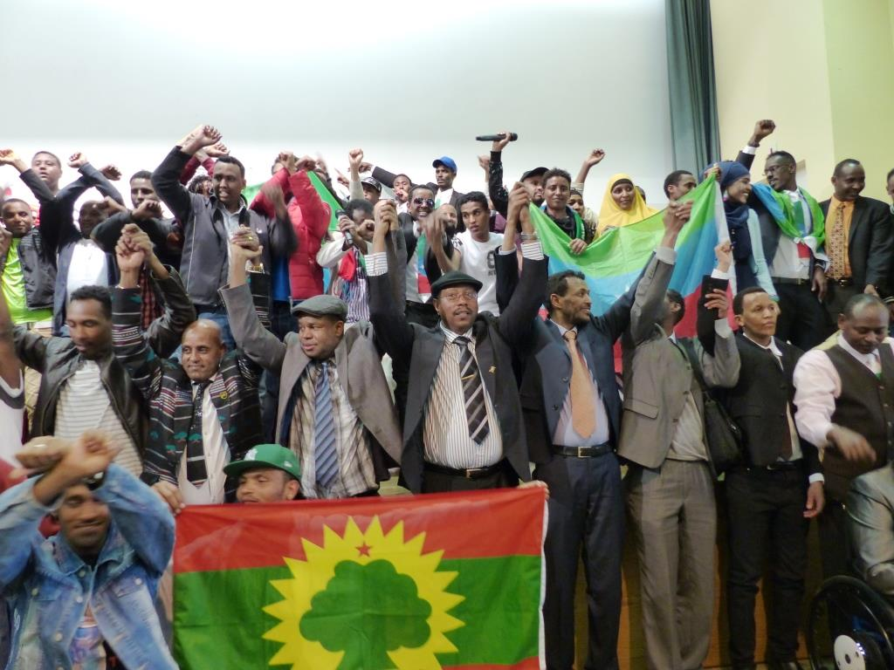

The Peoples Alliance for Freedom and Democracy (PAFD) public meeting hosted by Oromo Student Union and Ogaden Community in Germany was held on 9th of April 2016 in Frankfurt am Main, Germany.
It was attended by two Executive committee members of PAFD, human rights advocators, invited guests, Veteran members of successful liberation movement, representatives of youths and Women and generally by the peoples and nations of member organisations of PAFD.
On this meeting, paper was presented by the officials of PAFD on the current political situation in the Horn of Africa with special emphasis on Ethiopia. The objectives of the PAFD were also explained. The atrocious nature of EPRDF across the empire, images and videos of the ongoing protest and public resistance from Oromia have been presented. Artists have entertained with cultural music in between discussions.
Member Communities and other peace loving friends in Germany all gathered on this occasion have expressed their unflinching support and solidarity for the Alliance. They noted that the oppressed peoples in Ethiopia have now reached a tipping point where the outcry of the peoples under Occupation of the Ethiopian regime cannot be ignored any more.
After thorough discussions and comments on the presentations during the meeting the participants continued discussions on the various issues. Finally the participants concluded the meeting upon passing political resolution.
The Political Resolution of this public meeting in Germany: -
- Hereby in unison we convey our unflinching support for PAFD in its struggle against the TPLF/EPRDF-led Ethiopian regime, to regain the legitimate national right for the Nations and peoples. We also appreciate the outcome of PAFD congress that brought member organisations under one umbrella leadership to forge stronger bond of unity among member organisations which allowed them to strengthen their combined effort on diplomatic, political and armed struggle against TPLF. The participants of the meeting also summoned all nations and Nationalities in Ethiopia to create a firm ground for a unity of purpose and mutual respect. In the last twenty plus years TPLF/EPRDF has been tactically engaged in instigation of ethnic discord. We call up on our peoples to be aware of “divide and rule” colonial principle and resolve their conflict in a manner they used to live in it.

- The Ethiopian government is currently playing a destructive and destabilizing role in the Horn of Africa in general and on the peoples under its rule in particular. The Dictatorial regime run by the TPLF is currently using every means at its disposal to silence the quest of people for justice. Freedom of press, civil Societies and independent judiciary are non-existence in this country. The Regular army and Agazi militias are using brute force against innocent Oromo protesters with complete impunity; extra-judicial executions, enforced disappearances, arbitrary mass detentions and harsh prison terms under dubious laws are practiced beyond imagination. People are evicted from their ancestral land under the pretext of “Development” and “master plans”. We strongly condemn such belligerent act of Ethiopian regime.

- The partnership of EU with Ethiopia is aimed to bring a political environment guaranteeing peace, security and stability, which are the solid ground for sustainable economic policies and developments. Respect of human right violations, sustained economic growth, developing the private sector, increasing employment, good governance and etc. are the main witness and visible criterion for the objective of the partnership. Concerning the current Tigryan Peoples Liberation Front (TPLF) led regime of Ethiopia, there is massive evidence, which demonstrates beyond any doubt that the government is intensifying the persecution of Ogadeni, Oromo, Sidama, Gambella, Benishangul and other nations and nationalities in the empire. We appeal to the international communities in general and EU to implement ACP-EU agreement and its resolution passed on 21st January 2016.

- The public meeting appreciated Resolution of EU, Concerns of some democratic governments and honours Amnesty International, Human Rights Watch, Human rights League Horn of Africa, Oromia Support Group, Ethiopian Human Rights Council and International Commission of Jurists for their principled and responsible activities in exposing the atrocities of TPLF government behind the curtail. Although the effort of these humanitarian organisations are limited to exposure, as it ought to be as a matter of rule, the participants of this public meeting values this contribution to be immense in bridling the militant and aggressive nature of the TPLF regime.

- It is clear that the EPRDF force's violent manoeuvre is intensifying from day to day. People are being denied to lead peaceful life. Such deplorable act has to be unequivocally condemned by all peace-loving forces. Therefore, we call upon all peoples in the empire of Ethiopia to join us in the struggle against the EPRDF regime.

- We also call USA, EU and AU to refrain themselves on current deal with TPLF's regime about the Oromo protest behind the curtail without the consent of peoples in Ethiopia and particularly in this case the Oromos.
Peace and justice shall prevail!

9 Apri 2016 Frankfurt, Germany

